Revision History
Date | Version | Description | Author
17/10/2016 | 0.01 | 2.1 User Requirements Specification updated. | Mehmet Uluç Şahin
18/10/2016 | 0.02 | 1.1 Document overview and 1.2 System overview. Giving necessary information for RMS. And 1.3 Abbreviations. | Mehmet Melih Arıcı
18/10/2016 | 0.03 | Modeling an Activity Diagram for RMS. (2.3 Usage cases and scenarios) | Mehmet Melih Arıcı
18/10/2016 | 0.04 | Added 2.2 System Architecture | Arda Mutlu
18/10/2016 | 0.05 | Added 1.5 Conventions  Added 2.4 System Requirements Specification | Eren Balatkan
19/10/2016 | 0.06 | 2.4 System Requirements updated and revised | Berkay Bayram
25/10/2016 | 0.07 | 2.3 Usage Cases and Scenarios updated. Activity Model deleted. UML use case diagram and Sequence diagram added. | Mehmet Melih Arıcı
26/10/2016 | 0.08 | 2.2 System Architecture revised | Arda Mutlu
26/10/2016 | 0.09 | 1.3 Abbreviations updated  1.2 System Overview updated  1.5 Conventions updated  2.1 User Requirements Specification revised | Mehmet Uluç Şahin  Berkay Bayram  Eren Balatkan

TABLE OF CONTENTS
1 INTRODUCTION 3
1.1 Document overview 3
1.2 System overview 3
1.3 Abbreviations 3
1.4 References 3
1.5 Conventions 3
2 REQUIREMENTS 5
2.1 User Requirements Specification 5
2.2 System Architecture 6
2.3 Use Cases and Usage Scenarios 6
2.4 System Requirements Specification 7

INTRODUCTION

Document overview
This document presents the software requirements specifications of RMS (Room Management System) software development project.

It describes requirements of functionalities, use cases, and scenarios.

System overview
Need for the system:

While there is a library reservation system for SIS, there is no system that gives students an opportunity to reserve study rooms in buildings. In some cases, students look for an empty study room but he or she cannot find it and it is just a waste of time.
In some other case, a student leaves his belongings to a study room and he spends his time at another place so that the study room is not used for studying. And other students who search for it, suffers because he or she cannot find an empty study room for studying. By using RMS, students can reserve rooms for 3 hours at maximum so that they cannot use these rooms for some irrelevant tasks.

RMS can work with SIS or LMS so that it can take necessary information for students, rooms, academicians and lectures from these systems.

Abbreviations
RMS : Room Management System
LMS : Learning Management System
SIS : Student Information System
ID : Identification
OZU : Özyeğin University
UR : User Requirements
SR : System Requirements

References

# | Document Identifier | Document Title
- | - | -

Conventions
Requirements listed in this document are constructed according to the following structure:

User Requirements =
SRS-UR-RMS-000
Title of XXX-000 requirement
Description of XXX-000 requirement

Version of XXX-000

System Requirements =
SRS-SR-XXX-000.1
Title of XXX-000.1 system requirement, which is related to the user requirement XXX-000
Description of XXX-000 requirement

Version of XXX-000

Version Requirements =

Version: Version number

REQUIREMENTS

User Requirements Specification

Non-functional requirements specified by customer is shown below.
SRS-UR-RMS-010
Time Requirement of Listing Empty Room Function
Room Management Software shall bring the list of the empty rooms in under 1.0 seconds.

V1.0

SRS-UR-RMS-020
Compatibility Requirement
Room Management Software should be compatible with operating system Windows XP or a later version.

V1.0

SRS-UR-RMS-030
Size Requirement
Room Management software should occupy less than 50 megabytes of hard drive space.

V1.0

System Architecture
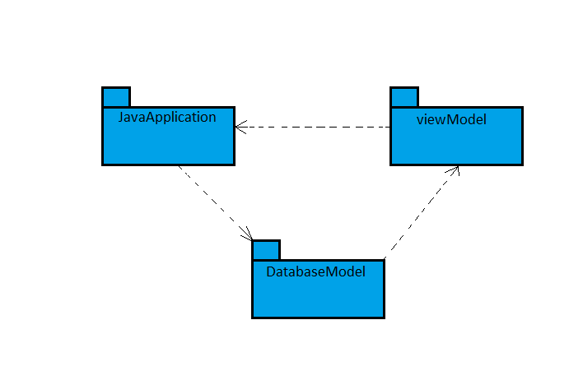

Use Cases and Usage Scenarios
UML USE CASE DIAGRAM:
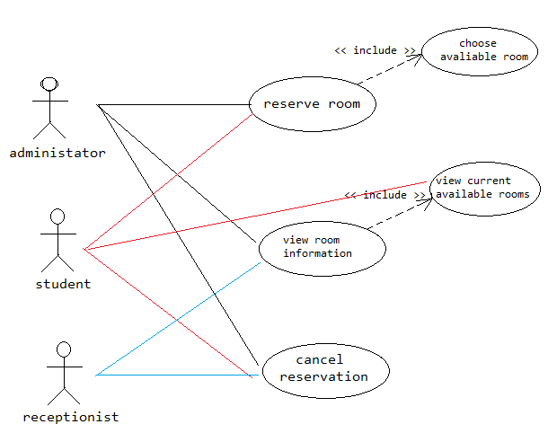
UML SEQUENCE DIAGRAM
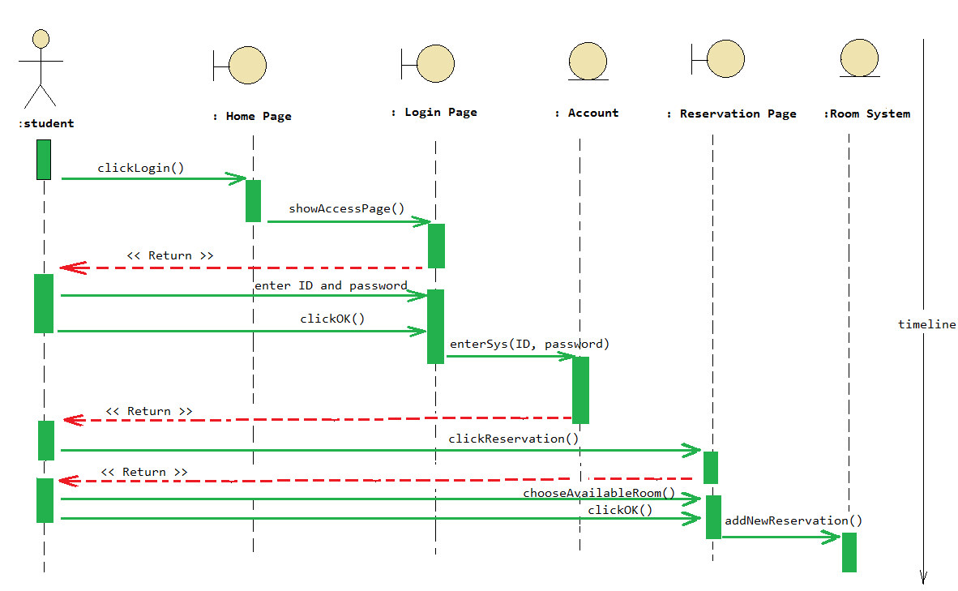

System Requirements Specification
SRS-SQ-RMS-010.0
Login system
RMS ensures that a user can login with his/her username and password:
- Username,
- Password,
V1.0
SRS-SQ-RMS-020.0
Database Connection
RMS connects database and pulls the data needed:
V1.0

SRS-SQ-RMS-030.0
Database connection
RMS ensures that the displayed room’s data are the same as requested room’s data.
The patient’s data are:
- Hours that the room occupied,
- Suitable for how many students,
V1.0

SRS-SQ-RMS-040.0
Room reservation
RMS tags the room as “reserved” and make it unavailable for taken period:
V1.0

SRS-SQ-RMS-050.0
Room reservation cancellation
RMS removes the “reserved” tag and make it available to students:
V1.0

